Answer to Question-1

|  |  |
| --- | --- |
| User Action | System Response |
| 1. User writes PIN number into Main screen | 1. System verify the validity of PIN and display different options of ATM to another screen. |
| 1. From system given options, user chooses “Withdraw money” option. | 2.The system shows a input box field to enter the amount for withdrawing. |
| 1. User writes the withdraw amount in input box field. And finally press submit button. | 3 . Validity is checked by the system after user submission that withdraw amount is valid or not. If it is valid ,Specific amount will be deduced from account holder’s account. At last User will receive money from ATM machine. |
| 1. User press button to get back his/her card | 4 . the system return the user card |

Answer to Question-2

Answer to Question -3

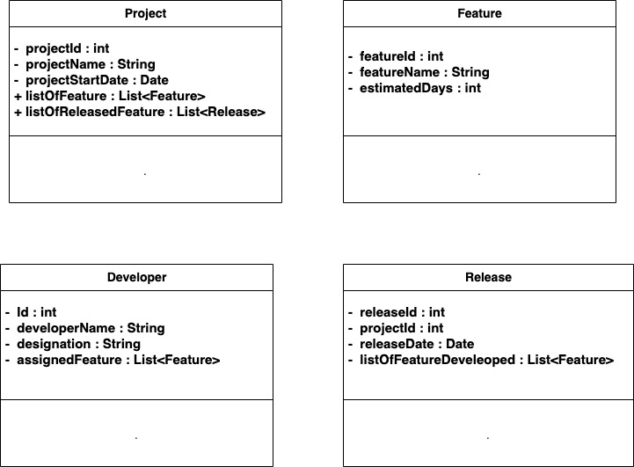

Note : for Question -3 , it is mentioned that [“you do not need to specify operations or associations. Also, you do not need to create a special class to represent the user interface ” ] . that is the reason , I did not mention any method specification.

Answer to Question-4

